II. Housing Price Economics

A. Demand for Housing
The main determinants of housing demand are:
- Population Size
- Population Growth
- Income
- Price of Housing
- Cost and Availability of Credit
- Consumer Preferences
- Investor Preferences
- Price of Substitutes
- Price of Compliments

The income elasticity of demand in North America is 0.5 to 0.9.
Price elasticity of the demand for housing services in North America is -0.9 to -0.7.

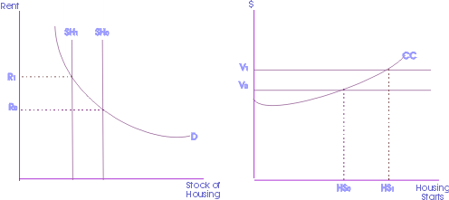
Figure 2.1: Rent and Housing Stock; Value and Housing Starts

B. Supply of Housing
The quantity of new supply is determined by the cost of inputs such as land, labor, and building materials. The price of the existing stock of houses and technology of production has an impact as well.

A typical single family dwelling in suburban North America has the following cost structure:
- Acquisition costs 10%
- Site improvement costs 11%
- Labor costs 26%
- Materials costs 31%
- Finance costs 3%
- Administrative costs 15%,
- Marketing costs 4%

Supply price elasticity depends on the elasticity of substitution and supply restrictions. There is significant substitutability between land and materials, as well as between labor and materials. In high-value locations, multi-story concrete buildings are typically built to reduce the amount of expensive land used.

Supply restrictions can significantly affect substitutability. In particular a supply shortage of skilled labor, land availability, and land use controls.

C. Housing and Economic Indicators
- Existing-Home Sales
- Pending Home Sales Index
- New-Home Sales
- Housing Starts
- Housing Affordability
- Mortgage Purchase Application Index
- Fixed-Rate Mortgage Rate
- GDP
- Consumer Confidence
- Unemployment Rate
- Consumer Price Index
- Producer Price Index
- Retail Sales

D. Market Equilibrium
1) Inelasticity of Supply and Demand
The market equilibrium is affected by elasticity of demand or supply, or the percentage change in one variable given a change in another. The price elasticity of demand for housing currently falls between -0.7 and -0.9, indicating demand for housing is relatively inelastic. This is a logical conclusion considering housing is a necessity good. With the elasticity of demand of housing relatively inelastic, any shift in the supply curve will have an affect on the ultimate market equilibrium. The demand curve may adjust relatively slowly given a change in supply.

The income elasticity of housing demand falls between 0.5 and 0.9, indicating the extent to which housing could have inelastic demand. The primary factor influencing home prices are income levels. Income elasticity of demand measures the effect on demand given a percentage change in income. Home prices are limited in how far they can rise by the incomes of potential buyers. Approximately eighty percent of all homes purchased are done so with a mortgage. The ability to make payments, borrow money, and the cost of borrowing influence how far prices can rise, because potential buyers are unable to qualify for larger loans.

2) Government Restrictions on Rent
In the short run, a controlled rent level below the market equilibrium causes a shortage in apartments. The supply and demanded analysis is indicated in Figure 2.2. Since it is less profitable to build with rental prices below the market equilibrium, in the long run no new building are constructed and the supply shortage magnifies.

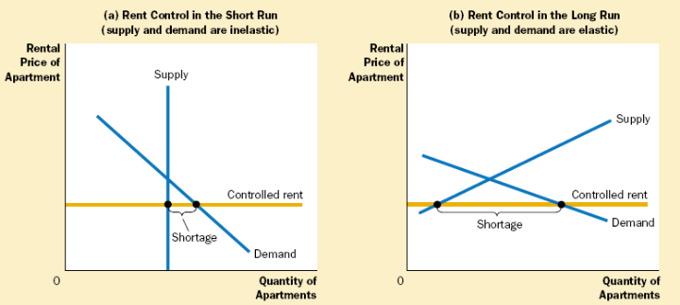
Figure 2.2: Short and Long Run Effects of Rent Controls

A price floor has the opposite effect of controlled rent if the price floor is above the market equilibrium. There is a surplus supply of housing as there are not enough people willing to pay the regulated price of housing.

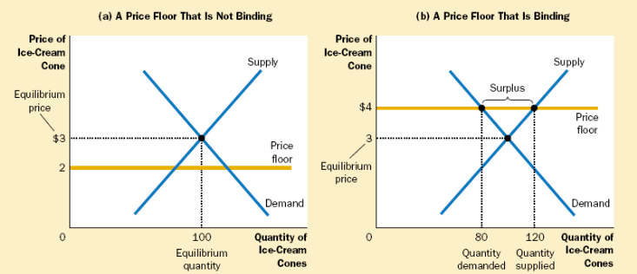
Figure 2.3: Binding and Nonbinding Price Floors

3) Taxes and Tax Credits

A tax levied on buyers causes a demand curve shift downward by the size of the tax. A tax levied on sellers causes a supply curve shift upward by the tax amount. In both situations, the tax causes the price paid by buyers rises, and the price received by sellers to fall. This causes a reduction in the equilibrium quantity, which corresponds to a contraction in market size. In the end, buyers and sellers share the burden of the tax, regardless of how it is levied.

The distribution of the tax burden, incidence of a tax, depends on the price elasticities of supply and demand. The burden tends to fall on the side of the market that is less elastic, because that side of the market responds by changing the quantity bought or sold.

Tax credits aim to have an opposite effect of a tax. Tax credits intend to increase the size of the market, as is the case with the tax credits for the Housing Market Recovery Economic Stimulus Package. Current legislation states that first time homebuyers are eligible for a $7,500 tax credit, given that they purchase the home after April 1, 2008 and before July 1, 2009. This tax credit is essentially an interest-free loan that requires repayment over a period of up to 15 years. In February 2009 Congress passed an $8,000 tax credit for first time home buyers. Note that this credit does not need to be paid back, unlike the original $7,500 first-time homebuyer tax credit. To qualify, the purchase has to be made between January 1, 2009 and November 30, 2009. Additionally, the homeowner must stay in the house for three years.

4) Other Factors of Market Equilibrium
Local economic strength, state and municipal zoning, neighborhood features (such as quality of schools), and the condition of the property itself all play a role in shaping the equilibrium for housing markets.

E. Economics of Housing Bubble
The surplus in housing stock has been created from the era of loose lending standards and low interest rates that has caused a decline in prices. The demand for housing has dropped significantly, because access to credit has deteriorated and the majority of homes are purchased with a mortgage.

The Austrian Business cycle theory claims the bubble was created from a significant increase in borrowing and lack of saving, prompted by overseas borrowing and monetary pumping by the Fed. Housing prices were inflated by the speculative fever, and the prevailing sentiment that housing prices will never drop.

http://mises.org/journals/scholar/Thornton13.pdf

